Aventuras de Annalisa:

Design Documents

Jessica Shoemaker

Purdue University

**Concept Document**

Aventuras de Annalisa is an educational game intended to assist elementary aged children in learning basic Spanish language skills. The player will be lead around several countries in Latin America by a tour guide, Annalisa. After the learning activities, they will complete a drag and drop activity which will help them to learn the vocabulary by matching it contextually into a story in the form of a social media post.

Each vocabulary topic will be presented to the learner utilizing both Spanish and English. There will be a mixture of text and audio narration which will alternate between Spanish and English. Learners will progress through different levels and as skills are acquired, more Spanish will be included in written and verbal forms.

In order to create a meaningful learning experience, Aventuras de Annalisa will appeal to the young learner’s interests by incorporating a social media experience into the game. The game will build upon the social media idea by using “likes” to score the knowledge check portion of the game for correctness.

**Table of Contents**

**Introduction 3**

**Target Audiences and Implementation Context 3**

**Learning Objectives 3**

**Hooks 4**

**Game Mechanics 4**

**Artificial Intelligence 5**

**Game Elements 5**

**Story Overview 5**

**Game Progression 6-8**

**User Interface 8**

**Implementation Artifacts and Guidelines 9**

**Art Bible 11**

**Game Minute 11-12**

**Introduction**

It is commonly accepted that by the time we reach adulthood, our capacity to effectively learn a new language is exceedingly diminished. The prime age to learn a new language tends to be in childhood, typically during the elementary years. In order to capitalize on this ideal timeframe for linguistic learning, Aventuras de Annalisa will take children on a journey, exploring three Spanish-speaking countries- Mexico, Nicaragua and Puerto Rico. Each country (level) will contain 3-4 different locations that the player will need to visit to learn basic Spanish words and phrases as they complete each level.

When visiting each of the locations, the learner will complete two activities. The first will be an exploratory activity. The player will be introduced to a few Spanish words or phrases, as well as learn about different cultural aspects of the country they are visiting. Next they will be lead through a guided dialogue to practice what they have learned.

**Target Audiences and Implementation Context**

As indicated above, the intended target audience of the will be elementary age children. However, the game will appeal to all age groups who wish to improve their Spanish language vocabulary. The game will be implemented in an individual, online learning environment. However, there is also an opportunity for use within the classroom. For classroom use, Aventuras de Annalisa can be used as a supplement to a Spanish language lesson or as a cultural immersion activity for geography or social studies.

**Learning Objectives**

Using the Spanish language, learners will be able to:

1) Introduce themselves

2) Understand basic Spanish phrases and respond.

3) Build a foundational vocabulary in the areas of travel, personality/hobbies, family/relationships.

4) Engage in brief conversations solely in Spanish.

**Hooks**

Aventuras de Annalisa will take learners on an adventure. While learning the Spanish language, the player will also learn about the countries they are visiting and the intricate nature of their cultures. In order to engage and motivate the learning experience, Aventuras de Annalisa will reward the learner with points for correct answers. At the end of each level, the points can be redeemed for souvenirs which will serve as a badge of completion.

This game will be unique because of the focus on learning about the culture and countries visited in addition to Spanish language acquisition. Most linguistic games that I have experienced are very high level, sticking to just the language. While I love Duolingo for its simplicity and focus on the language, I am a culture-obsessed person. I want to learn about the places and cultures who speak the language I’m learning. Immersion is essential for language acquisition.

**Game Mechanics**

Players will be guided through the learning experience by Annalisa. She will serve as a travel director and cultural guru. Annalisa will show the game player around each country. At each location within the country, she will help the learner explore and study the country and its culture. The exploration phase will assist in learning Spanish vocabulary. Annalisa will teach the player about Dia de los Muertos while visiting Merida and about Mayan culture when visiting Chichen Itza. During each of these exploratory stops, she will speak both Spanish and English- following up a Spanish word or phrase with its English equivalent. Each topic they learn about will broaden their knowledge of the language as well as the culture.

The second part of visiting each location will include a knowledge check type of activity. Using some of the words and phrases they learned in the previous activity, the game player will write a social media post about the city/country they are visiting. They will be given a picture to describe using a mad lib style transcript. Utilizing the mad lib technique, the player will select the appropriate Spanish word from a drag and drop setup.

**Artificial Intelligence**

The artificial intelligence piece for Aventuras de Annalisa will be encompassed within the Adobe Captivate software. Captivate has prebuilt knowledge check and “question” slides which have the functionality to measure correctness of an answer and calculate scores.

**Game Elements**

Annalisa will be the main character in the game. Supporting characters will be introduced within each city and country visited. The introductory level, set in Mexico, will include a tour guide named Juan at Chitzen Itza and a teenage girl named Maria celebrating her quincenera in Mexico City.

During the knowledge check activity, the player will be awarded “likes” similar to those utilized on a social media platform such as Facebook or Instagram. At the completion of the activity, the likes will be totaled to indicate the players score.

**Story Overview**

Annalisa will introduce herself as the guide through this experience. She will explain that she is a student on summer vacation. Her Spanish teacher has offered an extra credit assignment to complete over the summer. Students can earn points by writing posts in Spanish on their social media accounts about their activities and explorations throughout the summer. However, Annalisa forgot to pack her tablet when she left home for her travels to visit family in other countries and can’t post to social media herself. She needs your help!

**Game Progression**

Screen 1: This is where Annalisa will verbally introduce herself. The Start box in the middle of the screen will act as a button to move the player forward.

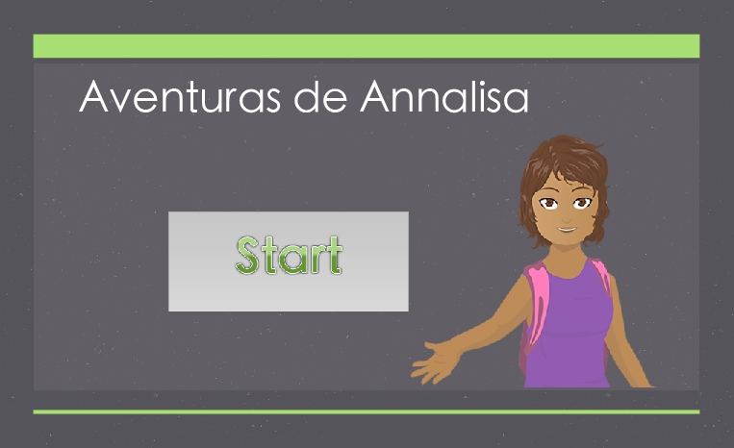

Screen 2: When fully developed, this page will act as a landing screen for “travel” throughout the game. The big box to the left takes the player to the Mexico levels, small box in the middle to Nicaragua, and far right takes the player to Puerto Rico.

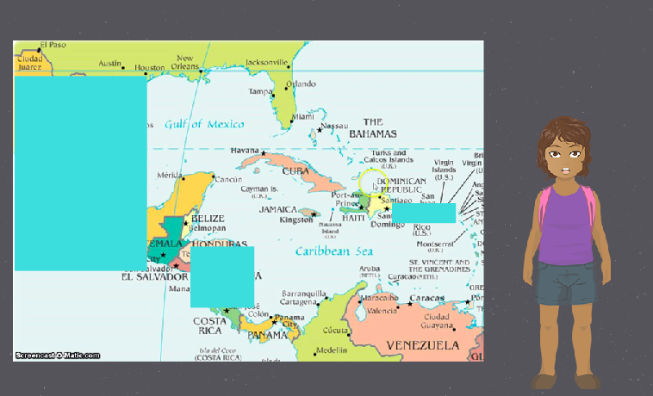

Screen 3: This will be the landing page for Mexico, with rollovers for each of the areas the player will be visiting.

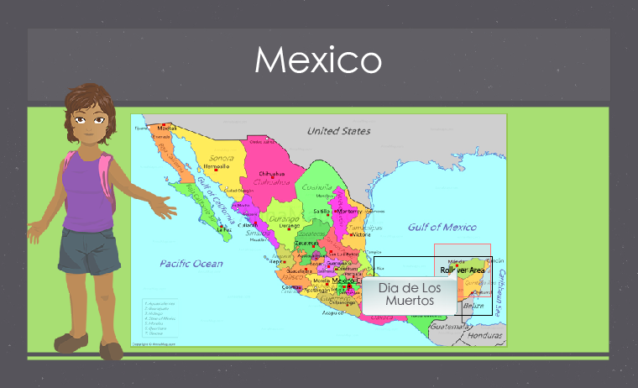

Screen 4: This will be a learning page. I don’t have it fully fleshed out right now, but there will be additional pictures and learnings.

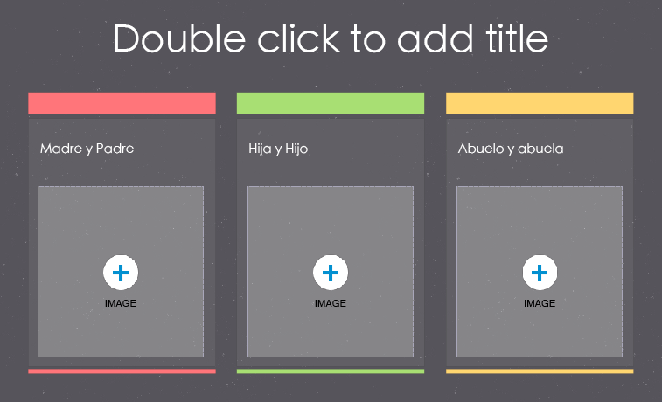

Screen 5: This will be a learning about the cultural context. A brief audio explanation of Dia de los Muertos will be given and additional family related vocab will be utilized.

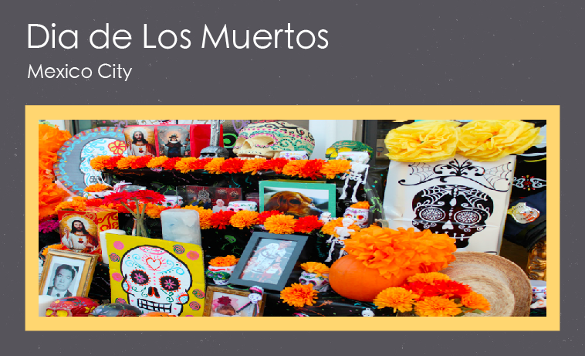

Screen 6: I am potentially adding a video to this page about Dia de los Muertos or Mexico City.

Screen 7: This will be the knowledge check/challenge of the level. The paragraph in the middle will be the “social media post” and there will be several more blank spots. The player will then drag and drop into the paragraph.

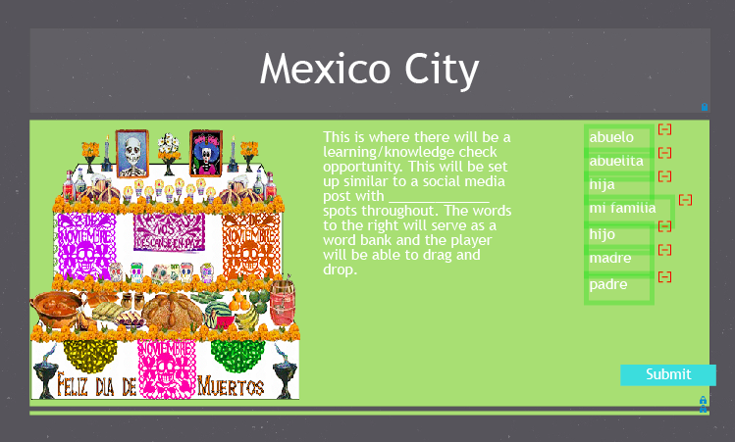

**User Interface**

The user interface for Aventuras de Annalisa will be either a PC or Mac. The game will be created using the software Adobe Captivate. It will then be published and playable utilizing any computer which has an internet connection. At this time the user interface is not designed to be suitable for mobile devices.

**Implementation Artifacts and Guidelines**

Aventuras de Annalisa has two primary options for gameplay. One would be in an informal environment (such as the game player’s home or at another location where they have computer access). The second, more formal location is in a traditional classroom or as part of a homeschool curriculum.

***Informal Implementation***

In an informal, non-classroom environment, Aventuras de Annalisa can be used to as a supplement to Spanish homework as a method of practicing simple vocabulary. The artifacts necessary for operation in this contact are simple. The learner would simply need a computer and internet access. If utilized by the parent, the game can be presented as a reward for focusing on and completing required homework, as well as a technique for helping their child study a subject they may not know well enough themselves.

***Formal, Classroom Implementation***

For classroom use, Aventuras de Annalisa can be integrated into either a Spanish language course or a social studies lesson. The game would be a great supplementary activity, especially as an option for students to play either solo or in groups while the teacher helps those who are struggling. This way the students are staying engaged even when they are done with the actual lesson for the day.

Option 1: After completing the lesson for the day, the teacher typically walks around the classroom helping those who need extra assistance with assignments and homework. For solo play, the students who have completed their homework and all class work, should be given the opportunity to play the game. Teachers can create an updateable scorecard, where the players’ scores can be tallied and awards of small or large value can be given.

Option 2: As part of a Spanish or social studies class, Aventuras de Annalisa can be used in alongside a standard lesson. A sample lesson plan is provided below.

**Materials:**

* Computers with internet connectivity (for accessing the game)
* Table
* Bright colored paper
* Family pictures of students (students should be instructed prior to the lesson to bring in a picture of a loved one who has passed or of their entire family)

**Subject Area:** Spanish or social studies

**Lesson (Spanish class):**

* Teacher will begin the lesson with a brief overview of family vocabulary in Spanish, sticking with the words students would most commonly use on a day-to-day basis (mi familia, madre/padre, hermano/hermana, abuelo/abuela). Later during the lesson, vocabulary can be expanded to include additional vocabulary (hijo/hija, tio/tia, primo/prima, etc.)
* After introducing the vocabulary, a brief discussion about the holiday, Dia de los Muertos should follow
* The class will then be instructed to decorate a small display for the Dia de los Muertos table using the bright colored paper, family picture, and other art supplies
* As students finish up their Dia de los Muertos craft, they will be allowed to transition to a computer in order to play Aventuras de Annalisa
* Class will conclude with a debrief about the students’ impression of the holiday, encouraging use of Spanish words

**Lesson (social studies):**

* Teacher will begin by introducing the festivities of Dia de los Muertos, with a strong focus on the cultural and historical background of the holiday
* Students will be encouraged to share either similar cultural practices they participate in with their family
* Utilizing the bright colored paper, art supplies and pictures they have brought in, students will create displays for a Dia de los Muertos table
* Finally, students will transition to computers to play Aventuras de Annalisa

**Art Bible**

The visuals throughout the game are bright, bold colors on a grey background. The template for the screens, as well as the character images, are both free asset downloads from the e-learningbrothers.com Captivate Asset Library. The vision for the game was inspired by the beauty and vibrancy in Latin American cultures. Additionally, the bright color scheme was chosen to appeal to the targeted audience. Refer to the game progression section for images.

**The Game Minute**

Game play will begin with a brief introduction by Annalisa. She will begin the story (as outlined above and instruct the player to click Start when they are ready to proceed. The player will then be taken to a map of Mexico and Central America. The countries of Mexico, Nicaragua and Puerto Rico will act as interactive buttons. At this time, only a portion of the Mexico level will be developed. Once fully developed, the player will have the option to choose which country to visit first. From there, they will then be able to determine which city/activity to visit.

For the purpose of the game prototype for this course, the level covering family vocabulary will be fully developed. The learner will click on the country of Mexico which will take the player to a map of the country. There will be four different areas to visit. Mexico City, Merida, Chichen Itza, and Puerta Vallarta. Merida will be the level fully developed for the prototype. When the player moves the mouse over Merida a box will pop up with the words “Dia de los Muertos.” This pop up will act as a button and take the player to the level.

Upon entering the city of Merida, the player will learn about Dia de los Muertos. There will be a brief description using key words and phrases, a short video about the holiday, and finally the knowledge check activity using the vocabulary words to create a social media post.